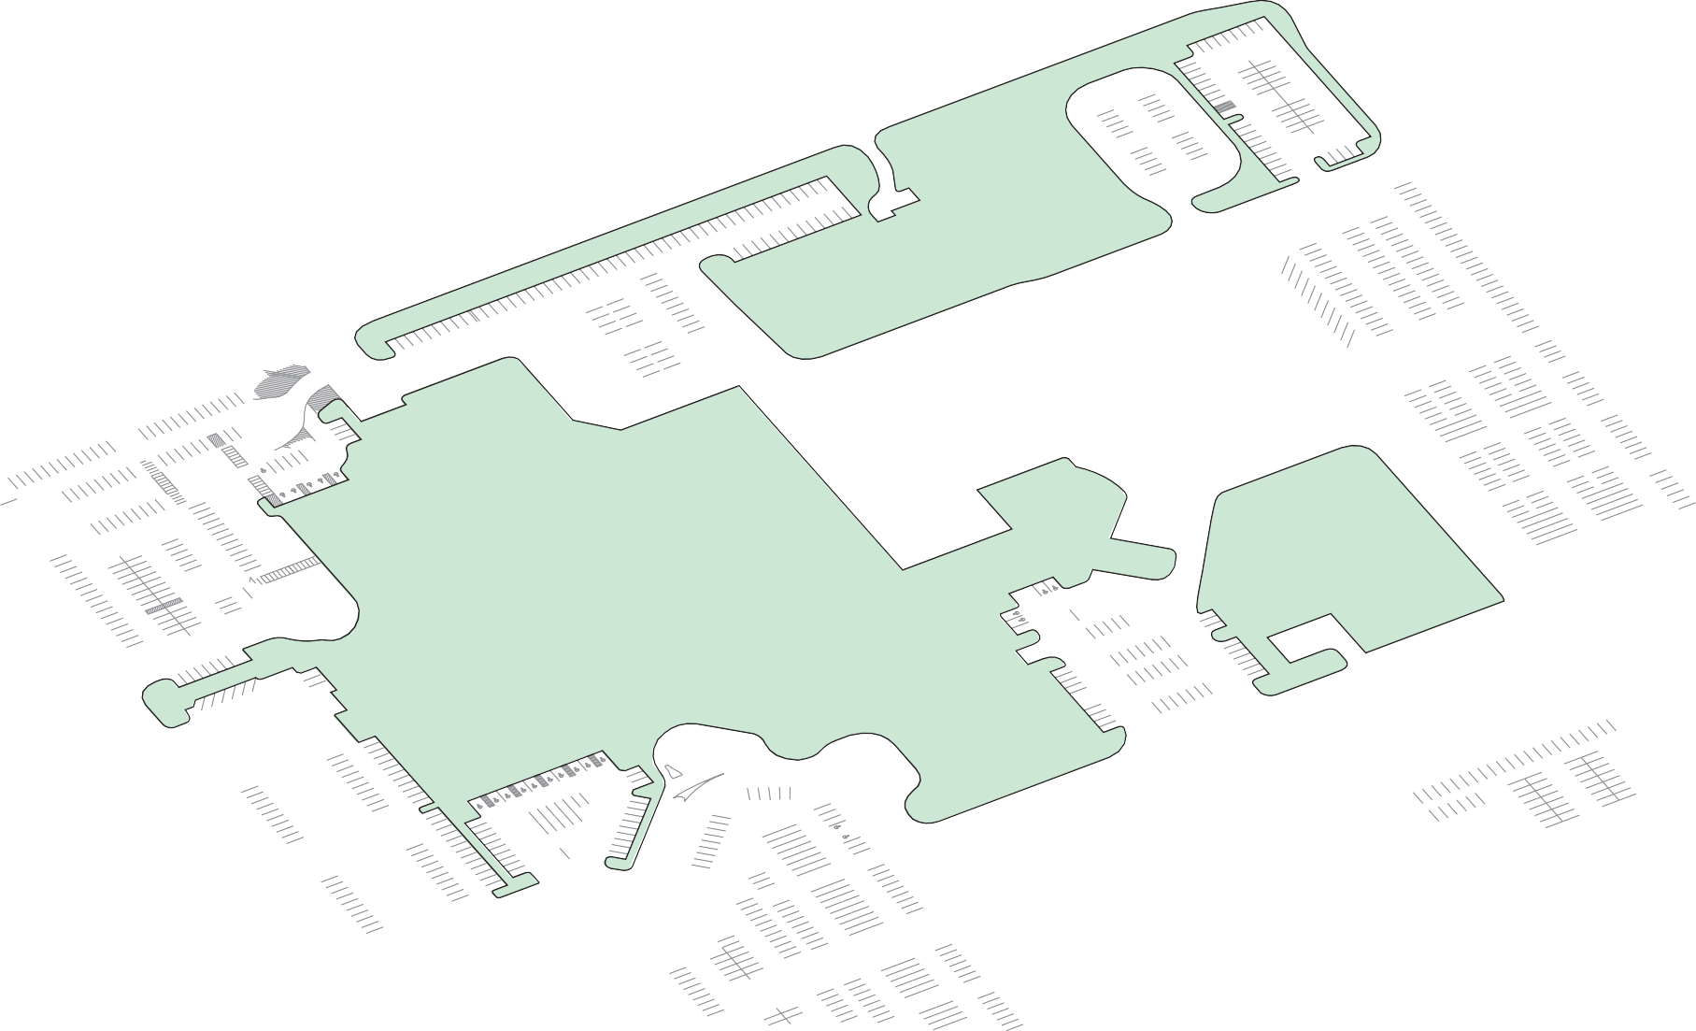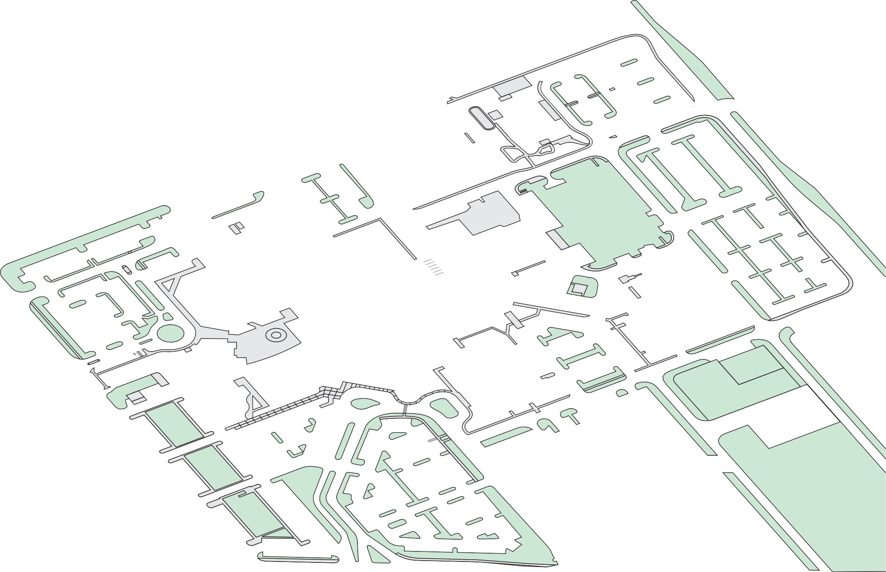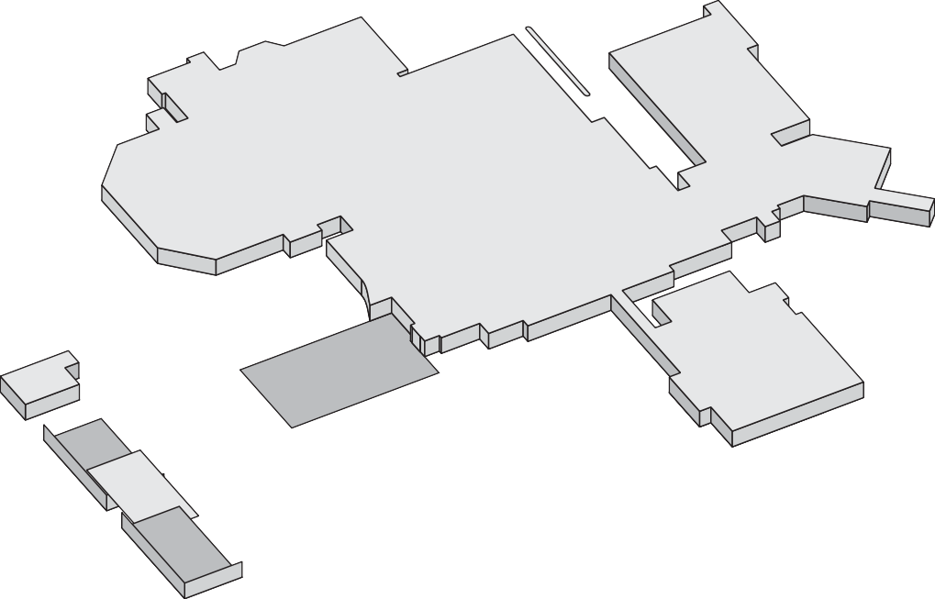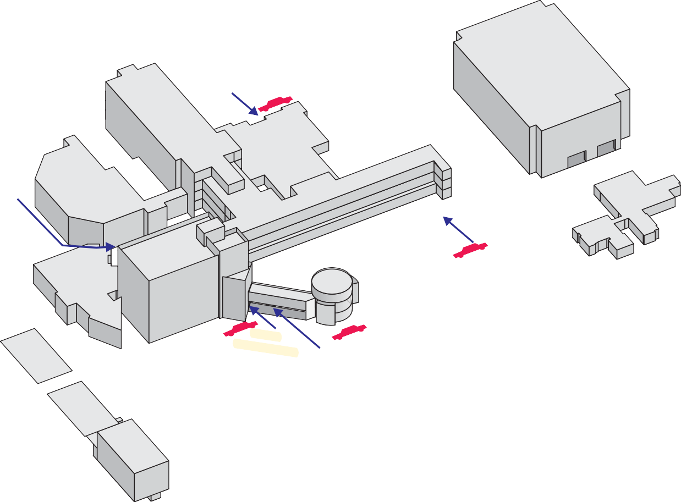

= Valet Parking

December 11, 2008

**NORTH FEDERAL HWY**

**N.E. 20TH TERRACE**

**SOUTH**

**ENTRANCE**

**MAIN**

**ENTRANCE**

*To I-95*

*EAST COMMERCIAL BLVD.*

*A1A*

***N.E. 49TH STREET***

***N.E. 48TH COURT***

***AMBULANCE ENTRANCE***

***N.E. 48TH STREET***

***NE 47TH ST***

**NE 19TH AVE**

GALLAGHER

BUILDING

EMERGENCY

JIM MORAN

HEART &

VASCULAR

CENTER

RESEARCH

INSTITUTE

MAIN BUILDING

***EXIT ENT.***

C

CHAPEL

MICHAEL &

DIANNE

BIENES

CANCER

CENTER

B

A

**N.E. 20TH AVENUE**

Human Resources 3rd Floor Suite A-38 Hours: Mon-Thurs

9AM-12PM & 1PM-3PM

Patient

Parking

Colleague Parking

Colleague

Parking

Garage

**Patient Parking**

**Emergency**

**Room**

G

Colleague

Parking

Colleague Parking

Patient

Parking

**Neuroscience**

Colleague Parking

OUTPATIENT

**OUTPATIENT**

Patient

Parking

**ENTRANCE**

INNOCENT

SISTER

CONFERENCE

CENTER

Patient

Parking

**BIENES**

**ENTRANCE**

**IMAGING CENTER**

Main

Patient

Parking

Patient Parking

Patient Parking

To Downtown Ft. Lauderdale